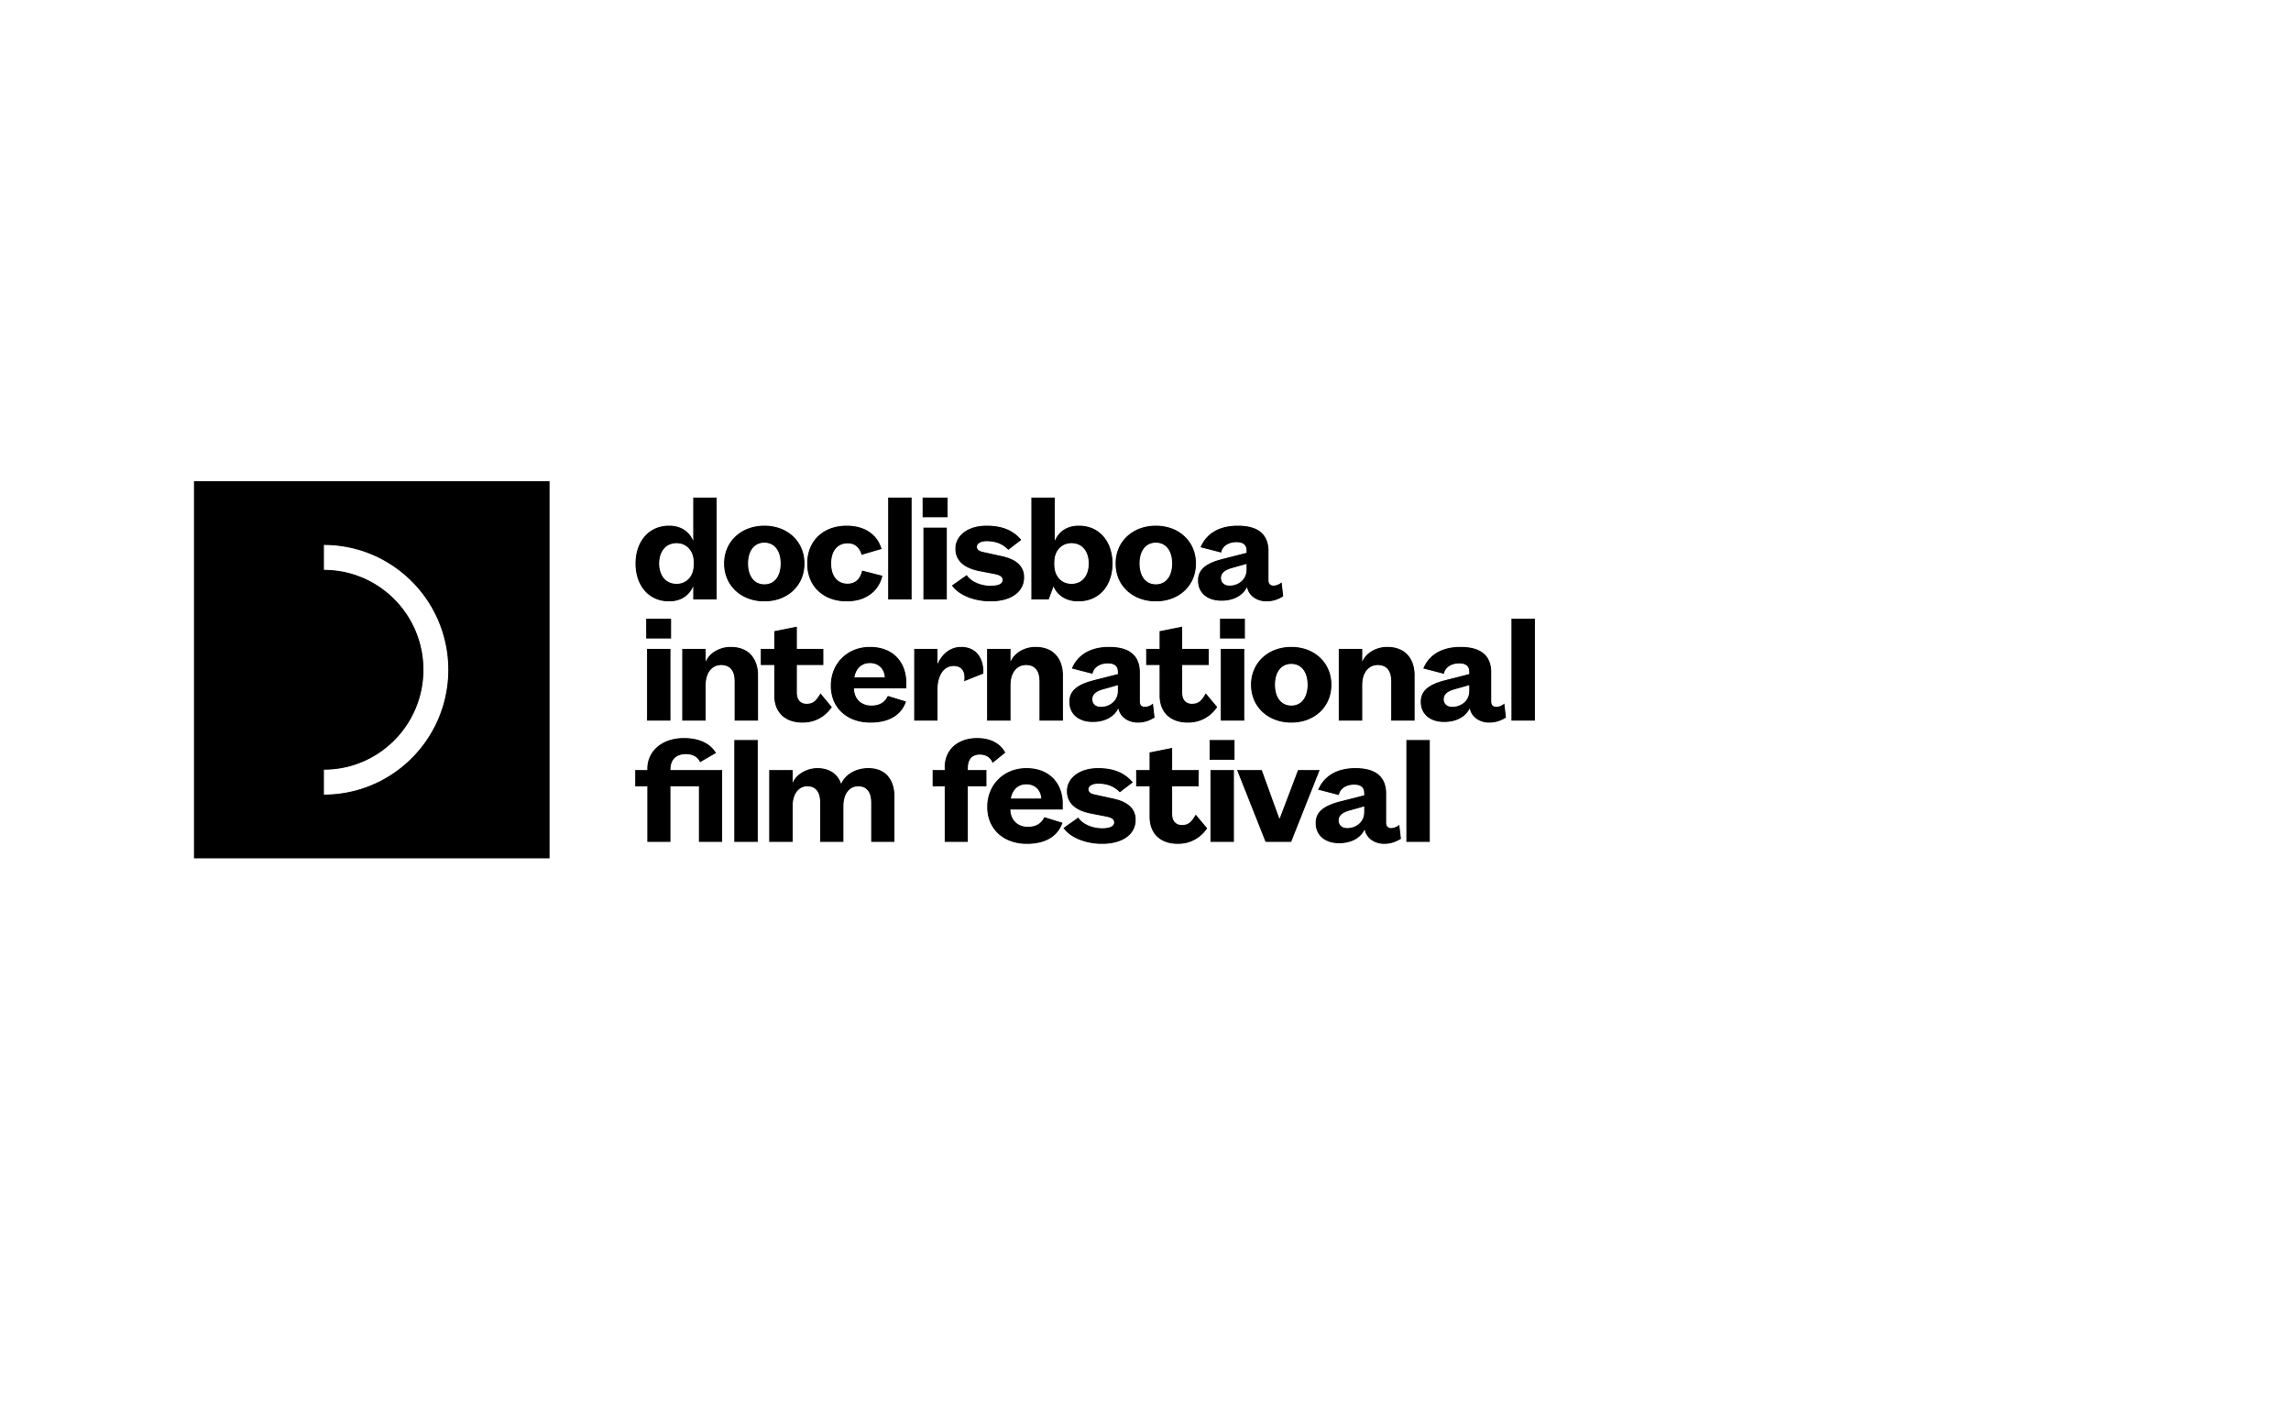

**19º DOCLISBOA AWARDS**

**International Competition**

City of Lisbon Award for Best International Competition Film

***918 Nights /* 918 Gau**

by Arantza Santesteban

The director builds a personal and political film, teasing and touching with the honesty and subtlety of her look. The work reflects upon the resistance to different overlapping control systems and does so by suggesting dialectics that question an oversimplified understanding of the forms of identity.

Canon International Competition Jury Award

***O Lugar Mais Seguro do Mundo /* The Safest Place in the World**

by Aline Lata, Helena Wolfenson

There’s a political and social commitment to the community and above all to the main character, given the caution with which his situation is followed and exposed over several years. The film fights against the indifference of human and environmental extractivism, while showing the importance of preserving natural and emotional places.

Honorable Mention

***Public Library /* Bibliothèque Publique**

by Clément Abbey

We highlight the filmmaker’s ability to find the networks connecting strangers in a place seen as individualistic. *Public Library* reminds us to reimagine public space, celebrating a community’s intimate everyday life.

**Portuguese and Short Film Competitions**

HBO Portugal Award for Best Portuguese Competition Film

**Distopia**

by Tiago Afonso

The film is not fighting only against gentrification that transforms the city but also against the gentrification of the minds, the images and the format of cinema.

For having found the just distance to portray the fight of a community for its rights, we unanimously award *Distopia* by Tiago Afonso, for the HBO Portugal award for Best Portuguese Competition Film.

Portuguese Authors Society Portuguese Competition Jury Award

**Meio Ano-Luz / Half a Light-Year**

by Leonardo Mouramateus

For its simplicity and subtly narrative with which the film highlights a Lisbon corner full of History, the jury, unanimously, decided to assign the Portuguese Authors Society Portuguese Competition Jury Award to Meio Ano-Luz, by Leonardo Mouramateus.

Schools Award

***Distopia***

by Tiago Afonso

This competition was a journey that started with a short film intimately looking at the relation between a mother and a daughter and ended with a letter from a father to a daughter that turned into a generational portrait on migration. It was a very difficult choice between short and feature-length films, all of them outstanding and each with its unique vision and social relevance.

The film we point out, in the words of its own director, is born out of activism and its images are the result of the action taken. A work made over the course of several years that is both a portrait and a chronicle of continuous and ongoing suffering, caused by gentrification in the city of Porto. Its images and structure introduce a need for action from everyone experiencing them. This is why we decided to hand the Schools Award to *Distopia*, by Tiago Afonso.

**Cross-Sectional Competition**

TVCine Channels Award for Best First Feature-Length Film (over 60’) from a selection comprising all sections with the exception of the retrospectives and Cinema of Urgency

***You Are Ceausescu to Me /* Pentru mine tu ești Ceaușescu**

by Sebastian Mihăilescu

Three years ago, I came to Doclisboa and Lisbon for the first time in one of the years when I was guest curator for MoMA’s Doc Fortnight. That year, I found a couple of films that I curated into the 2019 February programme. One was a short from here, *24 Memórias por Segundo*, that featured Portugal’s National Archive of the Moving Images, where archivists discussed the powerful bond between people and the machines they work with that preserve moving images, where cultural heritage and memory are kept alive.

There’s a relation between this notion of filmic frames revealing a particular moment in history—of who we are, what we thought and felt—and our winning film, *You Are Ceausescu to Me*. In this experimental documentary from Romania, the director—Sebastian Mihăilescu, presents contemporary Romanian young actors who enact aspects of their national history that they may have never even known about, recreating scenes from the life of Nicolae Ceausescu, Romania’s head of state from 1967 until his execution in 1989.

Interspersed with the young men taking different turns playing the part of Ceausescu in various scenarios, the film uses quite a bit of archival material, with fast-cutting montages of photos and various documents, offering viewers a bit more of the historical background of the stories being acted out. We found this film to be a very innovative way to combine form and story, and to offer this particular Romanian cultural memory in a unique way.

Honorable Mention of the New Talent Award

***The Spark /* L’Étincelle**

by Valeria Mazzucchi, Antoine Harari

For the rhythm and energy of sequences, for the police conflict scenes, for raising our awareness on the critical topic of the environment and offering an alternative path. Also here in Lisbon, where the housing issue is a hot topic. The honorable mention goes to *The Spark*, by Valeria Mazzucchi and Antoine Harari.

Volvo Award for Best Short Film (up to 40’) from a selection comprising all sections with the exception of the retrospectives and Cinema of Urgency

***Gargaú***

by Bruno Ribeiro

For the use of personal records stored in a mobile phone in a time of sadness and farewells, this film promotes a reencounter of people and places with its archives and paths crossed by cows, bicycles and imagination. For this reason, the film we chose for the Volvo Award for Best Short Film of Doclisboa 2021 is *Gargaú* by Bruno Ribeiro.

Healthy Workplaces Film Award

***Yoon***

by Pedro Figueiredo Neto, Ricardo Falcão

For the concentration and trust in few essential elements that tell us about a travel in which distance can’t be bridged but only crossed, time becomes a space to be filled, and the hardest challenge is not to get lost in one’s own mind; for the way it embodies a renewed belief in the political power of a terse and elliptical style; for its brave cinematic endeavor to tell a story so many have been living, so few have been telling.

INATEL Foundation Award for Best Film Dealing with Cultural and Traditional Practices as well as Intangible Cultural Heritage from a selection comprising all sections with the exception of the retrospectives and Cinema of Urgency

***Nūhū Yãg Mū Yõg Hãm: Essa Terra é Nossa! /* Nūhū Yãg Mū Yõg Hãm: This Land Is Our Land!**

by Isael Maxakali, Sueli Maxakali, Carolina Canguçu, Roberto Romero

An ongoing film, like the abuse that today still tells the same story of 500 years ago: a story of occupation and extermination. A journey across the territory to rebuild a cartography for which a people fights so that it doesn’t vanish from their collective memory. There’s no need for gimmicks. The reality in front of the camera is enough. The reality of an ongoing war, uneven and with no end in sight, exposed in this film of resistance where the main characters claim the right to tell their own story in their language—the language of the *Tikmũ'ũn* people. “This land is our land!”, they keep saying in this film that asserts itself both as political and artistic gesture.

Fernando Lopes Award

***Sounds of Weariness /* Léssivés**

by Taymour Boulos

The award distinguishes a film that is experimental in nature and reflects a risky and original creative attitude handling images and sounds. At the same time, such experimental work does not exclude, but rather intensifies a human vibration that carries very specific emotions, which are capable of engaging the viewer.

Audience Award - Público Newspaper Award for Best Portuguese Film Comprising Competitions, New Visions, Heart Beat and From The Earth to The Moon

***Alcindo***

by Miguel Dores

**Green Years Competition**

ADU Award for Best Green Years Film

***Late August /* Tardo Agosto**

by Federico Cammarata, Filippo Foscarini

The Best Green Years Film Award goes to *Late August* for the patient observation of Sicilian nature in what concerns both image and sound. The authors leave the audience with strong images, at times beautiful, and at times disturbing. The film opens discussions about the relationship of the filmmakers with the persons, animals and nature around them, and it not only provokes aesthetic impressions, but also raises ethical questions.

Special Irmalucia Green Years Jury Award

***In Spite of Ourselves /* A cambio de tu vida**

by Olatz Ovejero, Clara López, Aurora Báez and Sebastián Ramírez

The special Irmalucia Green Years Jury Award goes to a bold, yet patient film, that seamlessly mixes direct cinema, carefully composed images and archival materials. What we appreciated the most was the film’s coherence and the directors’ inspiration to tackle a contemporary issue in a subtle, yet convincing way.

Pedro Fortes Award for Best Green Years Portuguese Film

***Meia-Luz***

by Maria Patrão

The Pedro Fortes Award for Best Green Years Portuguese Film goes to *Meia-Luz*, by Ana Patrão, a film inspired by the images she discovered at the film school from *Jaime*, the first film by António Reis. We appreciate the attentive look on the work of António Reis, but above all on cinema itself, through the seeming simplicity with which she shows us the images and the sounds, the silences and the light, for instance.

Honorable Mention of the Pedro Fortes Award for Best Green Years Portuguese Film

***Fora da Bouça /* Ours Is the Wasteland**

by Mário Veloso

*Fora da Bouça* presents a song in a poetic way, and at the same time makes us think about how memory shapes our minds.

**Arché Awards**

RTP Award for Best Project in the Editing or First Cut Stage

***Under the Flags, the Sun /* Bajo las banderas, el sol**

by Juan José Pereira

The jury has decided to give the RTP Award according to the current phase of production of the projects after discussing it with the direction of the Festival. After careful consideration and meetings with the filmmakers, we have agreed that this project is in an advanced enough phase to receive the Best Project in the Editing or First Cut Stage Award. It is an exciting project, which sheds light on a little known but very significant part of history, by exploring the rare and hard-to-find archive materials. In addition, it creatively weaves the very fact that a lot of this footage is unavailable into the story itself, questioning the reliability of historical accounts and memory. The RTP Award goes to *Under the Flags, the Sun*,by Juan José Pereira (Paraguay, Argentina).

McFly Award

***Handycam***

by Francisco Bouzas

The McFly Award goes to a bold and powerful project that quite literally gives a voice to the marginalised and invisible, the misunderstood and neglected. The two wonderful characters of this film get a chance to represent themselves and their communities and surroundings on their own terms, and the viewer gets an opportunity to reflect on the role and influence of moving images in present times from a rarely explored angle. The McFly Award goes to *Handycam*,by Francisco Bouzas (Argentina).

Selina Award for Best Project in the Development or Writing Stage

***BEA VII***

by Natalia Garayalde

The Selina Award goes to a project of rare, intimate strength about a character that is plucked out of his natural environment and ends up on the other side of the world in a very specific moment of history. Combining first-person testimony from archive footage with interviews, it tells a complex story in which the personal, the political and the historical are inseparably intertwined: *BEA VII*,by Natalia Garayalde (Argentina).

School of Arts, Universidade Católica Portuguesa Award

***As Mulheres do Pau-Brasil /* The Brazilwood Women**

by Thais de Almeida Prado

The Special Arché Jury Award for a Project in the Writing or Development Stage goes to a playful project that addresses serious questions with a lot of heart and spirit. It employs unconventional methods to explore very personal, yet relatable stories that focus on topical issues such as gender identity, sexual preference and representation thereof within a very specific environment, which only highlights their universality. The School of Arts, Universidade Católica Portuguesa Award goes to *As Mulheres do Pau-Brasil*,by Thais de Almeida Prado (Brazil).

Special Mention

***Orlando Furioso***

by Rafael Ramirez

The jury has decided to give out a special mention in order to provide visibility and put on the map an extremely imaginative filmmaker, whose family story is inherently cinematic and we would love to see on the big screen. We are confident that the exciting contrasts and specificities of this narrative, coupled with the director’s insight and talent, will make for an original and fulfilling viewing experience. The special mention goes to *Orlando Furioso*, by Rafael Ramirez (Cuba, Ecuador).

[**Press Kit**](https://www.dropbox.com/sh/det6eiveclykkpv/AAAJ6z5vyAnrvqPxBcP5Wfura?dl=0)